**Create a Storage account by enabling Hierarchical Namespace**

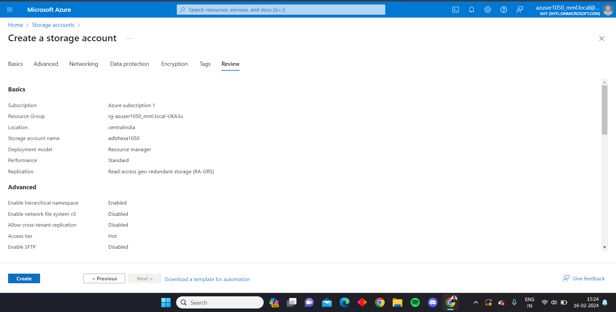

**It creates a ADLS gen 2**

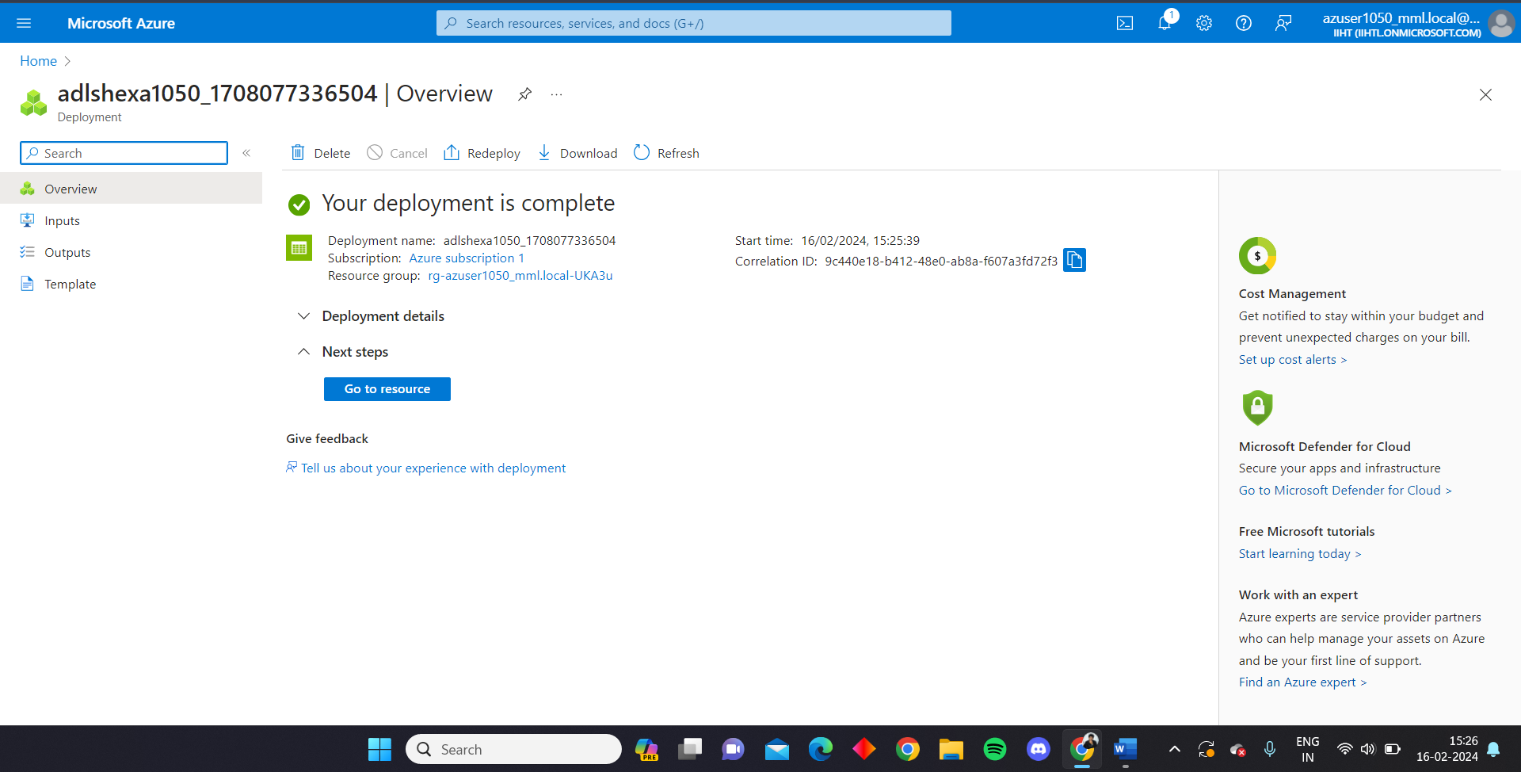

**Open the account**

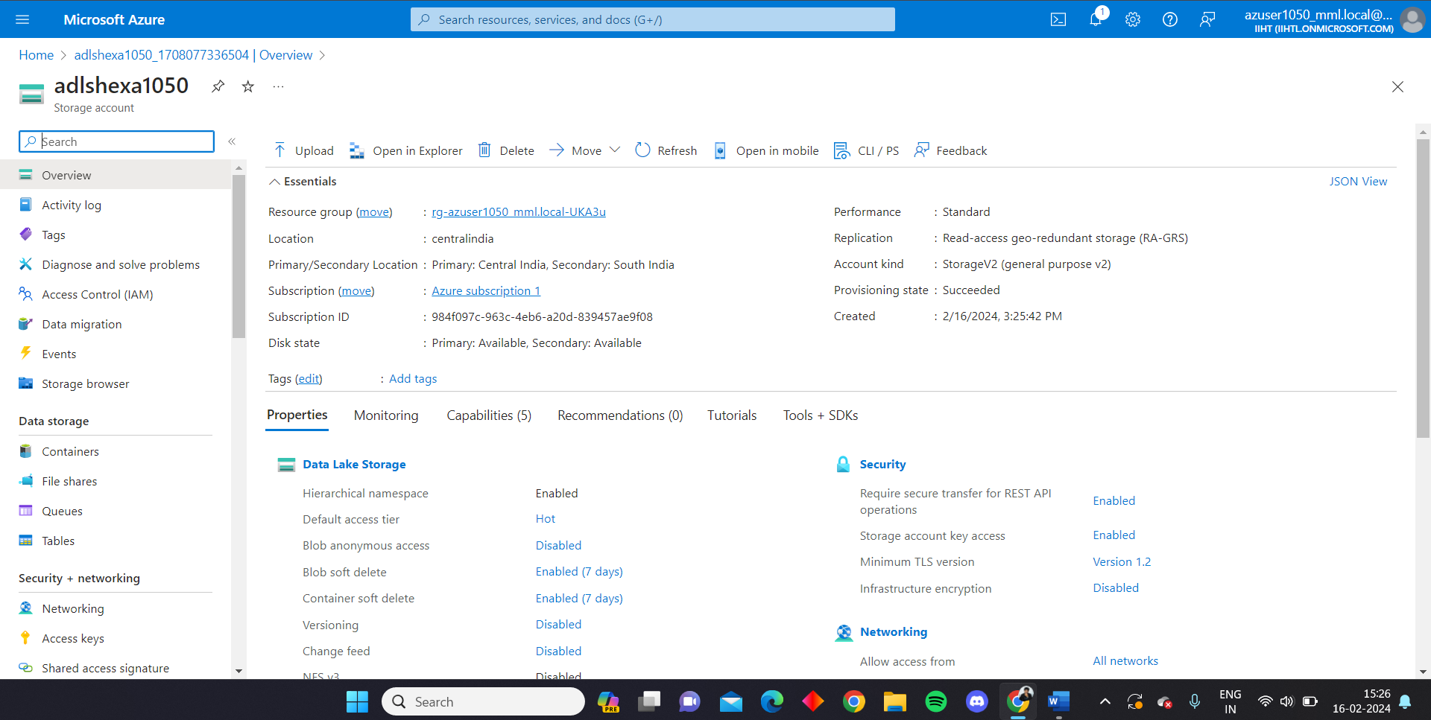

**Create a container**

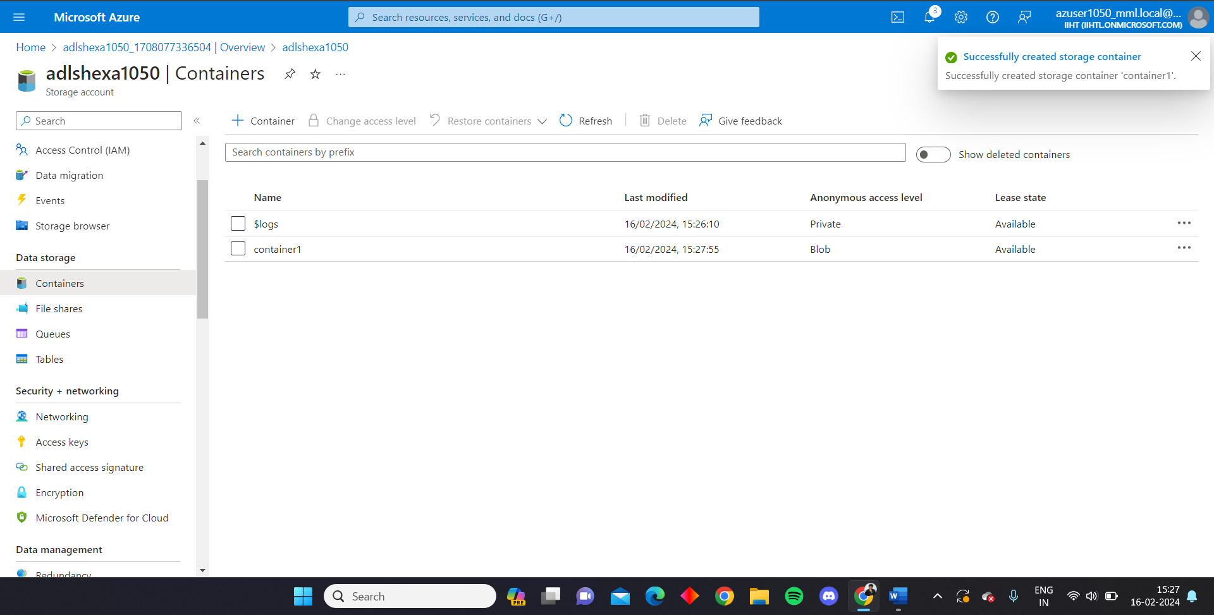

**Open the Microsoft azure storage explorer**

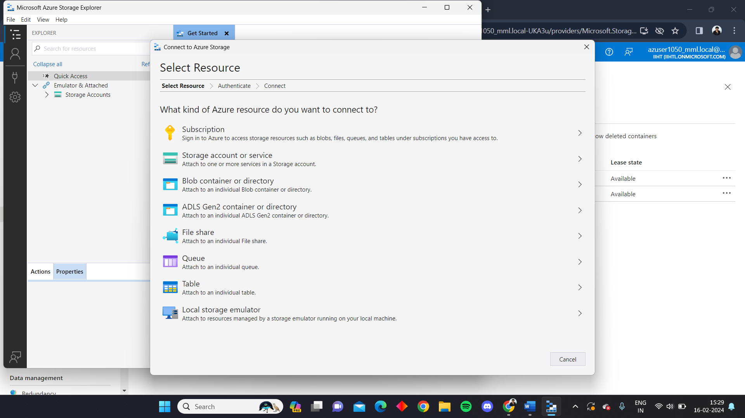

**Generate connection string for the storage account**

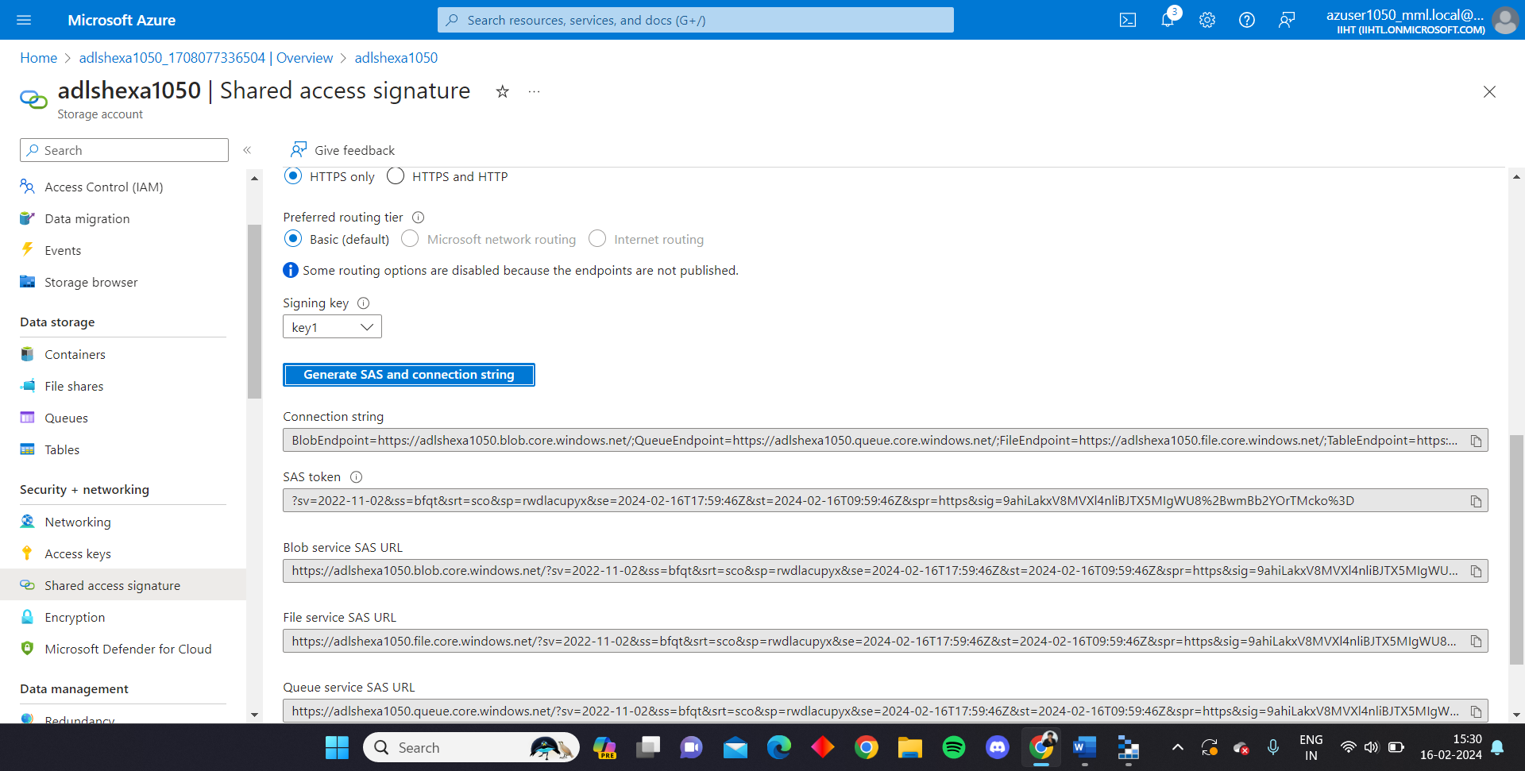

**Create a connection using the connection string**

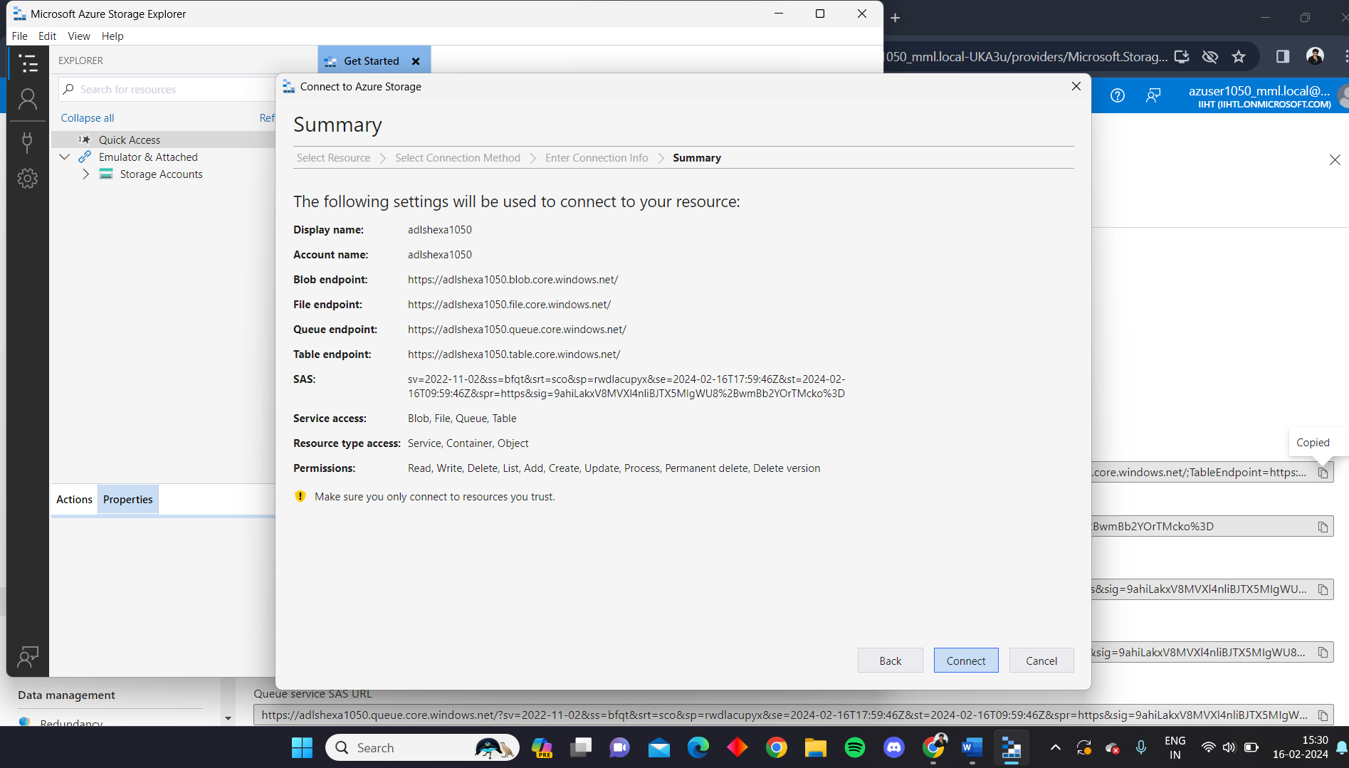

**Access the files in the container using the storage explorer**

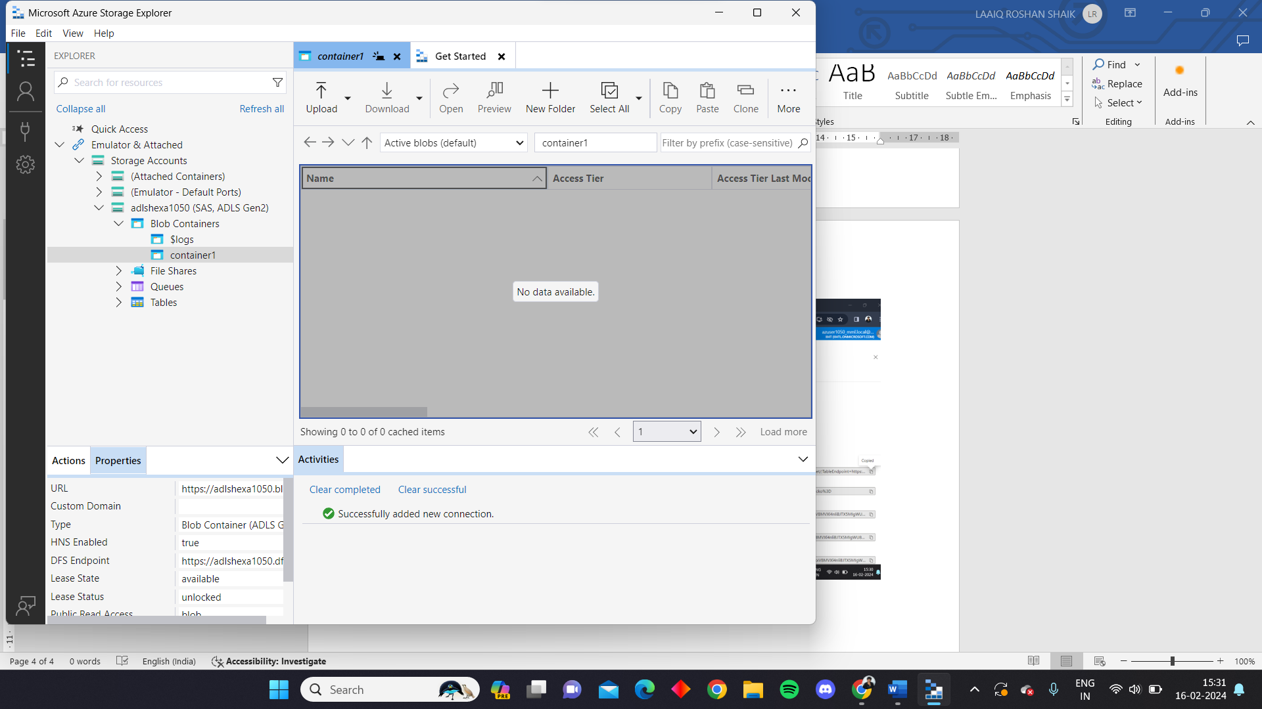

**After finishing the work detach the connection from storage explorer**

